Spanish

Tenses

Ar verbs

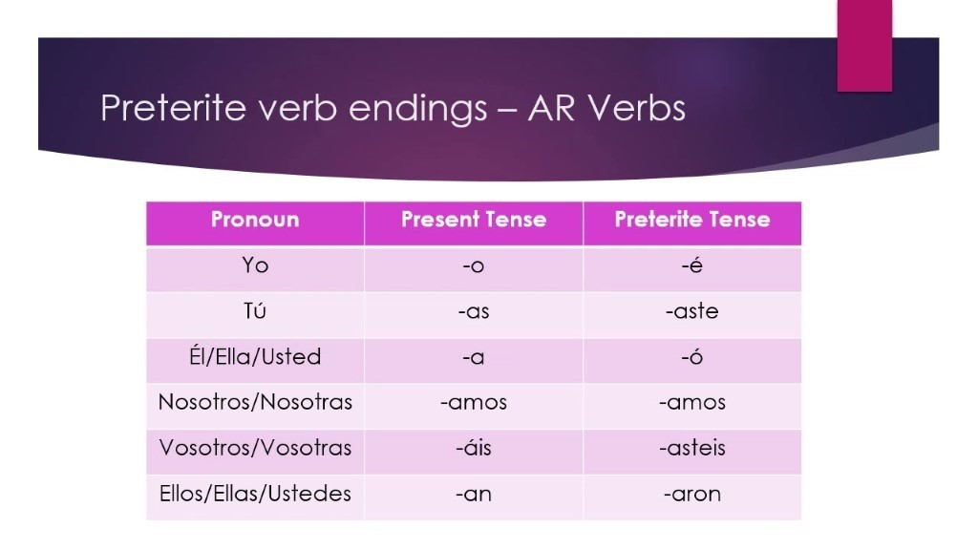

Er & Ir

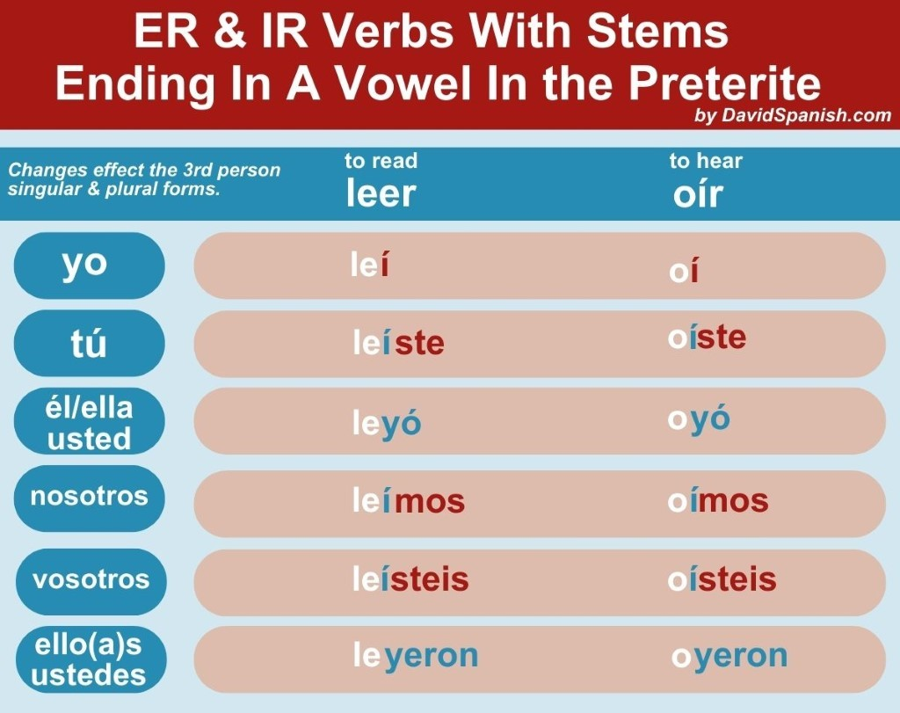

Exceptions

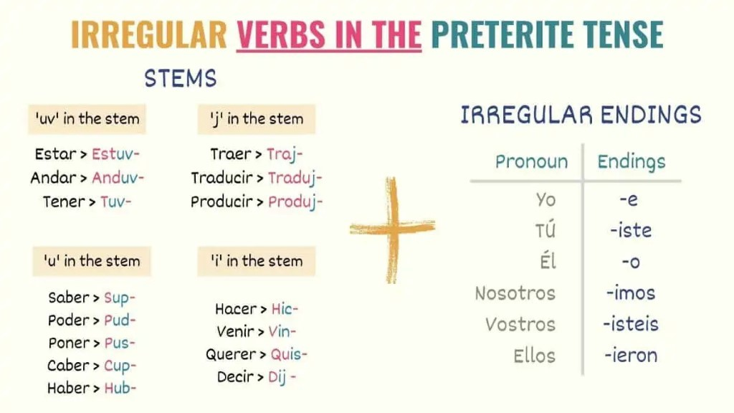
Future tense:
Voy a + infinitive

Reflexives
Me lavo
Te lavas
Se lava
Nos lavamos
Os laváis
Se lavan - ellos/ellas

Despertarse:
Me despierto
Te despiertas
Se despierta
Nos despiertamos
Os despiertais
Se despiertan

Acostarse:
Me acuesto
Te acuestas
Se acuesta
Nos acuestamos
Os acuestais
Se acuestan

Vestirse:
Me visto
Te vistes
Se viste
Nos vistimos
Os vistís
Se visten

Food

Eggs – los huevos
Fritos – fried
Pasados por agua – soft boiled
Revueltos - scrambled
Al horno – baked
La paella – rice dish
De marisco – with seafood
Negra – black
Valenciana – from valencia
Vegetaria – vegetarian
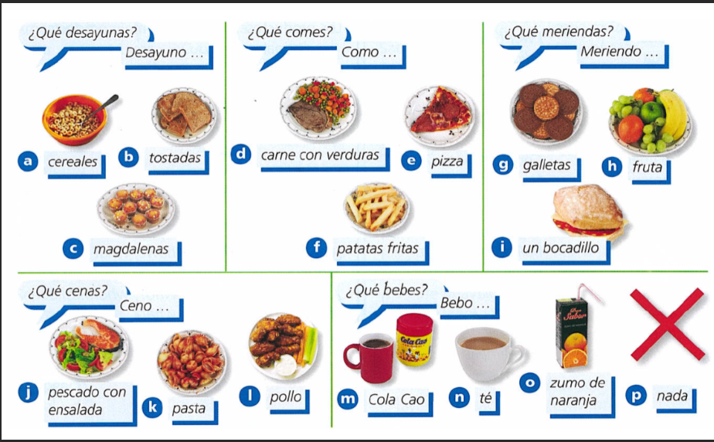

Chemistry
Year 9 End of Year Review 2026

1. Kinetic Theory
The arrangement and movement of particles in solid, liquid and gas, explanations of properties using ‘Particle Model’
Change of state (cooling and heating curves e.g. octadecan-1-ol)
What curves looks like, plotting, Identifying state changes on the curve and regions where solid, liquid or gas. Explanation of changes of state using kinetic theory
Diffusion – definition, random motion and speed of particles in fluids, effect of temperature
Experiments: i) Br₂ ii) NH₃ (ammonia) + HCl (hydrogen chloride) iii) KMnO₄ in water

2. Solubility
Measuring solubility
Factors that affect solubility
Effect of temperature on solubility
Solubility curves
Calculating solubility

3. Atomic Structure
The nuclear atom and sub-atomic particles.
Electronic Structure (e.g. K is 2,8,8,1) and how it links to the periodic table’s groups and periods.
Isotopes, definition, properties, Relative atomic mass calculation (weighted mean)

4. Ionic Bonding
Formation of positive ions (metals by loss of electrons) and of negative ions by gain of electrons
Electronic structure of ions (all have a full outer shell), charge on ion
Bonding by strong electrostatic attraction of oppositely charged ions
Transfer of electrons and diagrams (Dot and cross diagrams)
Giant ionic lattice Properties - Explaining properties in terms of structure and bonding

5. Metallic bonding
Metals (and non-metals) – characteristic properties
Metallic bonding.
Metallic Structure: Uses of metals and property use relationship; Physical properties (what affects its melting point, solubility, electrical conductivity in solid, liquid and solution in water); Explaining properties in terms of structure and bonding
Group 1 - Alkali metals
Appearance of elements, Pattern of reactivity and explanation (predicting Rb, Cs)
Action of air (stored under oil), Reactions with water and dilute acid
Oxides of these elements are basic, Flame colours
Group 2 - Alkaline Earth Metals
Action of air, Reactions with water (Ca) or steam (Mg) and dilute acids
Oxides of these elements are basic. Flame colours

6. Covalent Bonding
Covalent bonding- sharing a pair of electrons (single bond), double and triple bonds
Dot and cross: hydrogen, methane, oxygen, carbon dioxide, hydrogen chloride, nitrogen, water, ammonia
Shapes of methane (tetrahedral) and linear molecules/compounds
Simple Molecular compounds – Molecules; Intermolecular forces between two molecules; Physical properties (melting point, solubility, electrical conductivity and explanations); Explaining properties in terms of structure and bonding
Group 7 - The Halogens
Physical properties- appearance, state at room temperature, trends, explanations
Reactivity pattern and explanation (predicting F and At), uses
Halogen and halide displacement reactions

Across all topics - Formulae and Equations
Write formulae of compounds
Write balanced, symbol equations for chemical reactions

